Engine Installation – Airflow Performance FM200
TOPICS:EngineSection 43
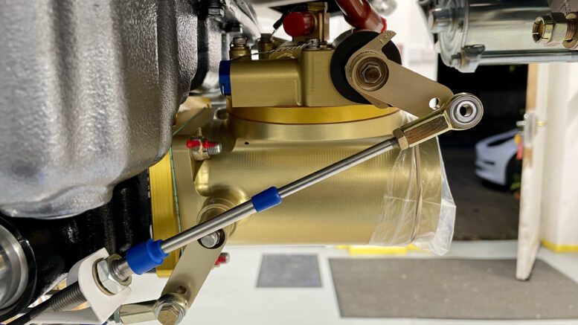
POSTED BY: STEVE OCTOBER 9, 2021

WD-00110 IO-390C Cables Bracket
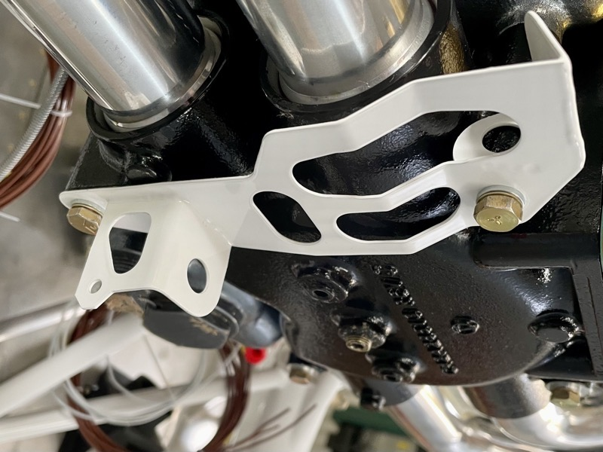
The EXP119 installation has a different cable bracket, which is bolted to the underside of the engine.
This is all very straightforward until you read the last sentence in the manual step:
“Torque the bolts per the Lycoming documentation”
Hmmm … !!
Many can be found in the corresponding Lycoming Series Engine Maintenance Manual or Installation and Operation Manual. If a value still alludes you, there is also a massive document … Lycoming SERVICE TABLE OF LIMITS AND
TORQUE VALUE RECOMMENDATIONS … but good luck!

FM200
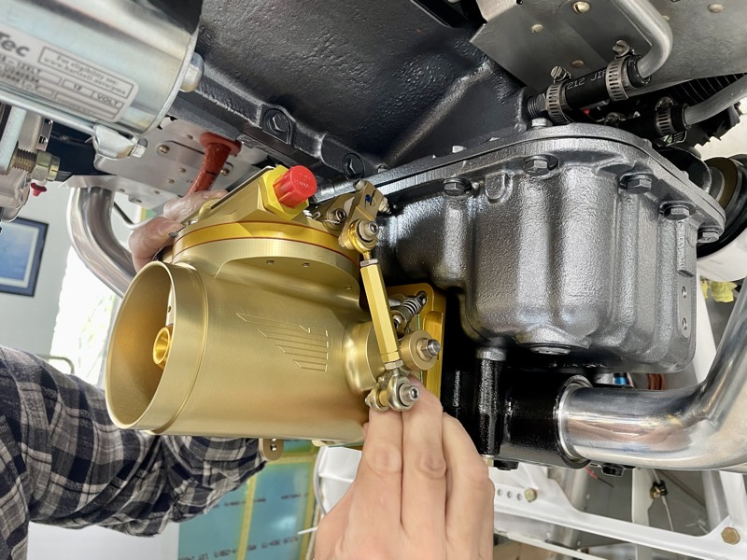
Our engine arrived with the Airflow Performance FM200 uninstalled, in a seperate box inside the crate.
There is a section in the relevant Lycoming Maintenance Manual about installing a Fuel Injector, and this mentions torque values for the attachment nuts.
But these really refer to the studs into the engine, and the EXP119 has a doubler already attached to these studs. This doubler has four studs, orientating the FM200 at a slight angle. This aligns the unit to enable access for the Throttle & Mixture cables from the bracket.

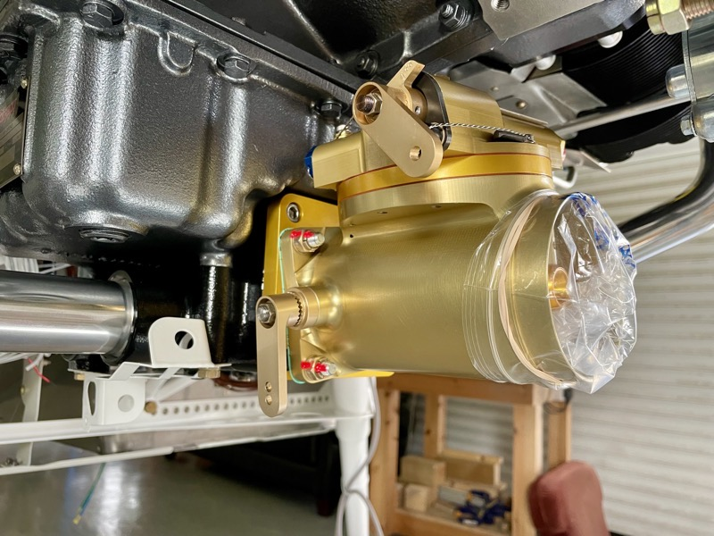
Our FM200 arrived with the Throttle lever on the left side, but it’s easy to swap it to the right side which is necessary for cable access.
The upper lever is Mixture, the lower one the Throttle.

Throttle & Mixture Cables
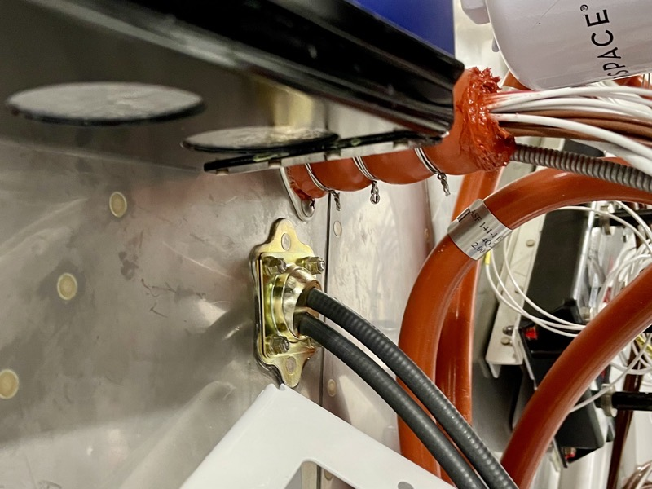
The cables route through the CT-00102 Double Spherical Grommet which was previously installed in the firewall.
This is a neat unit, and also leaves more space for wiring etc through the standard firewall penetration just above.

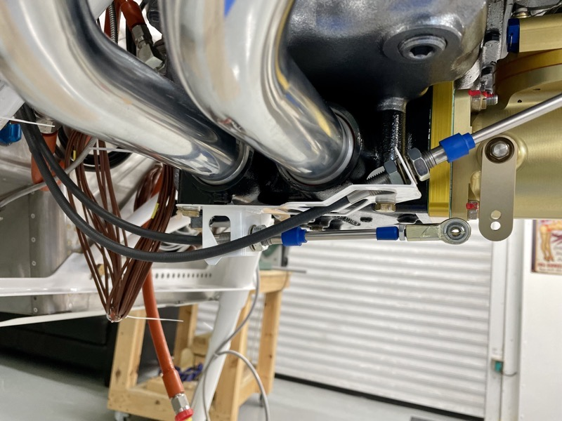
The cables route easily to the EXP119 bracket.

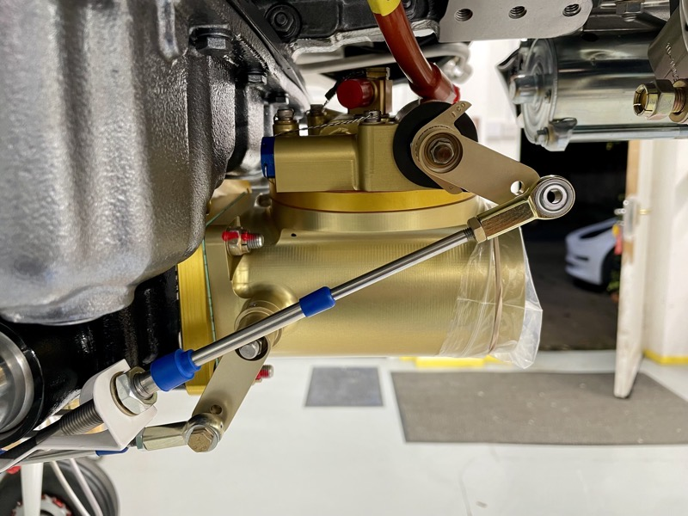
I found that the cable lengths from the bracket to the control levers were verging on being too long.
You can adjust them to be as short as possible by winding the cable attachment thread fully aft, and by screwing on the rod ends fully.
By doing this the throttle can be adjusted to provide a “cushion gap” in the cockpit, together with optimum geometry for the control lever across its travel.
“Optimum geometry” means that halfway through the lever’s range of travel, it’s at 90º to the cable.
The lever can be set at any angle to achieve this, but as can be seen in this picture where the cable and lever are at fully rich, the mixture cable was still too long when set at the required angle.

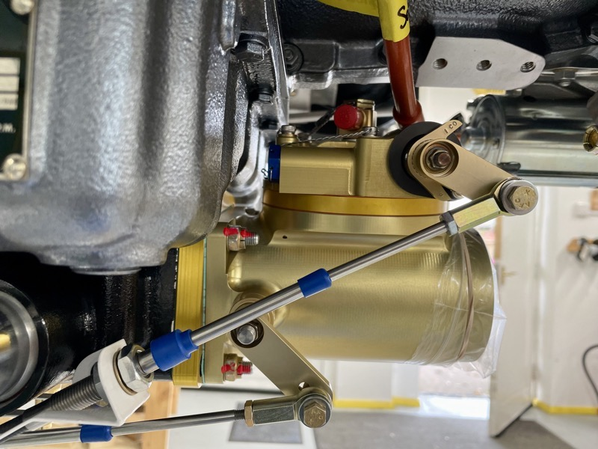
I solved this by trimming the very end of the cable threaded portion, allowing the rod end to be wound on another 1/8″ (it had bottomed out before using all the thread).
By winding the cable attachment at the bracket aft as much as possible, and by …

… accepting a slightly larger “cushion gap” at the mixture control knob in the cockpit, it just worked.
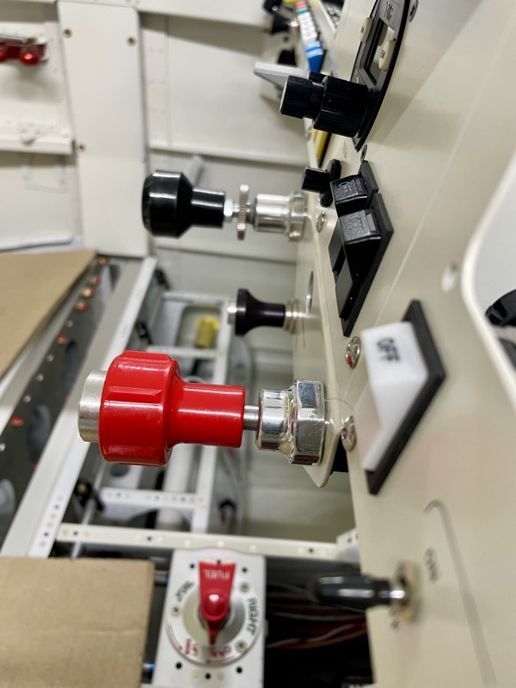

Links to other posts

